Development of control strategies for earthquakes reproduction on LNEC’s uniaxial shaking table

Desenvolvimento de estratégias de controlo para reprodução de sismos na plataforma sísmica uniaxial do LNEC

Afonso Costa Henrique^{1,2} | Miguel Ayala Botto² | Fernando Pires de Oliveira¹
¹LNEC – Laboratório Nacional de Engenharia Civil, Portugal ²IST – Instituto Superior Técnico, Portugal

Abstract
In the scientific area of earthquake engineering, while computational simulations have become highly sophisticated, it still faces limitations in accurately modelling complex, nonlinear, or poorly understood structural behavior. Numerical simulations, even with advanced methods, require experimental benchmarks to ensure accuracy. Moreover, machine learning approaches also rely on experimental data for training and updating models. Experimental testing provides critical validation and calibration for these models. In summary, earthquake experimental testing remains indispensable for model validation, understand structural complex behavior, and ensure structural safety. In this paper, a computational model of LNEC’s uniaxial shaking table is used to compare its performance with three distinct control strategies in terms of response spectra: the currently used method which consists on a iterative offline pseudo-adaptive open-loop control with the tests running in closed loop, a tuned PIDF controller, and optimal control. The results indicate that both the tuned PIDF and the optimal controller offer superior performance in terms of response spectra compared to the iterative method, with the optimal control providing the best results in every instance. However, the performance of each method depends on the system identification accuracy, whose sensitivity still being under evaluation.
Keywords: Earthquake Engineering, Control Systems, System Identification, Closed-loop Identification

Resumo
Na área científica da engenharia sísmica, embora tenha ocorrido uma melhoria no desenvolvimento de simulações computacionais, ainda se enfrentam limitações na modelação precisa de comportamentos estruturais complexos, não lineares ou outros pouco desenvolvidos. As simulações numéricas, mesmo com métodos avançados, requerem modelos experimentais para garantir uma boa precisão. Além disso, as abordagens de aprendizagem automática também dependem de dados experimentais para treinar e atualizar modelos. Os ensaios experimentais permitem por isso a validação e calibração desses modelos. Em resumo, os ensaios experimentais sísmicos continuam a ser indispensáveis para validar modelos, compreender comportamentos complexos e garantir a segurança estrutural. Neste artigo, um modelo computacional da plataforma sísmica uniaxial do LNEC é utilizado para comparar o seu desempenho em termos de espetro de resposta considerando três estratégias de controlo distintas: o método iterativo atualmente utilizado, que consiste num controlo pseudo-adaptativo offline em anel aberto e com o ensaio a decorrer em anel fechado, um controlador PIDF sintonizado, e o controlo ótimo. Os resultados indicam que ambos os controladores PIDF e o controlo ótimo oferecem desempenho superior em termos de espectros de resposta quando comparados com o método iterativo, sendo o controlo ótimo o método com o melhor desempenho em todas as simulações. No entanto, o desempenho de cada um dos métodos depende da qualidade da identificação do sistema, pelo que a sua sensibilidade ainda está a ser avaliada.
Palavras-chave: Engenharia Sísmica, Controlo de Sistemas, Identificação de Sistemas, Identificação em Anel Fechado

1- Introduction
The current shaking table platform testing process at LNEC consists on iteratively synthesizing a drive signal, distinct from the reference signal, such that the shaking table platform replicates the response spectra of the reference signal, i.e. the earthquake ground motion. At the end of each test, the system's performance is evaluated by comparing the response spectrum of the reference signal with that of the output signal measured on the platform. However, it is not always possible to achieve satisfactory performance with the command signal synthesized initially, and it may be necessary to generate more than one drive signal and carry out additional tests at the same amplitude. This procedure, although necessary in some situations, should be avoided as it induces additional damage to the structure.

2- Objectives
The objective of this work is to implement a controller, or strategy, to ensure that the shaking table platform reproduces the earthquake signal (reference/earthquake) as accurately as possible.

3- Control Strategies: Performance in simulation environment
Two control strategies, PIDF and the optimal controller, are being evaluated as a better approach to reproduce the earthquake ground motion on the shaking table. The results of numerical simulations show the superiority of these strategies (Fig. 1).
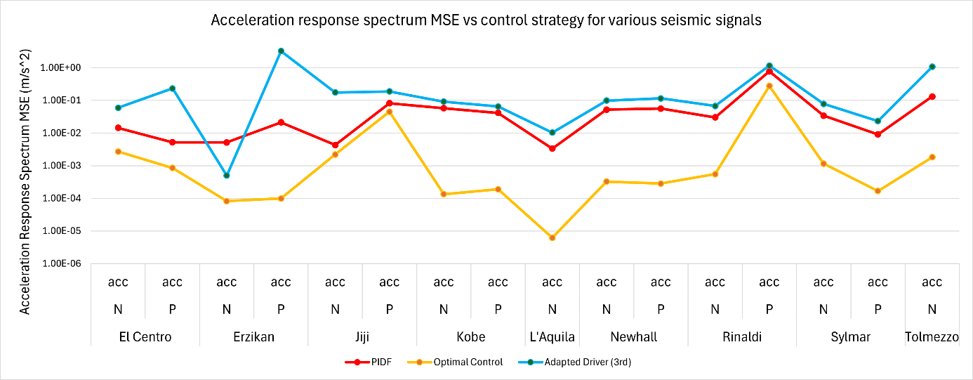
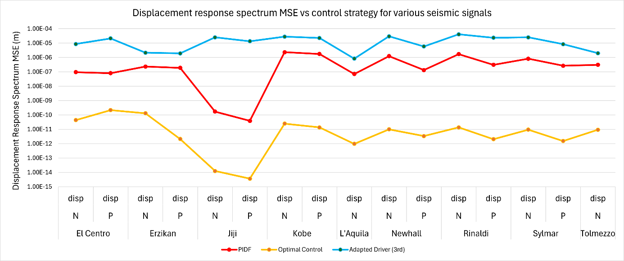
Fig. 1 | Accel. & Disp. response MSE under different earthquake signals for each control strategy.

4- Conclusions
The results indicate that the controllers previously studied offer superior performance in terms of response spectra compared to the adapted drivers, while also requiring less user intervention on the process, with the optimal control strategy providing the best results in every instance. However, both the performance of the controllers and the adapted drivers depend system identification accuracy, whose method sensitivity dependence on the quality of the identification is still under study.

